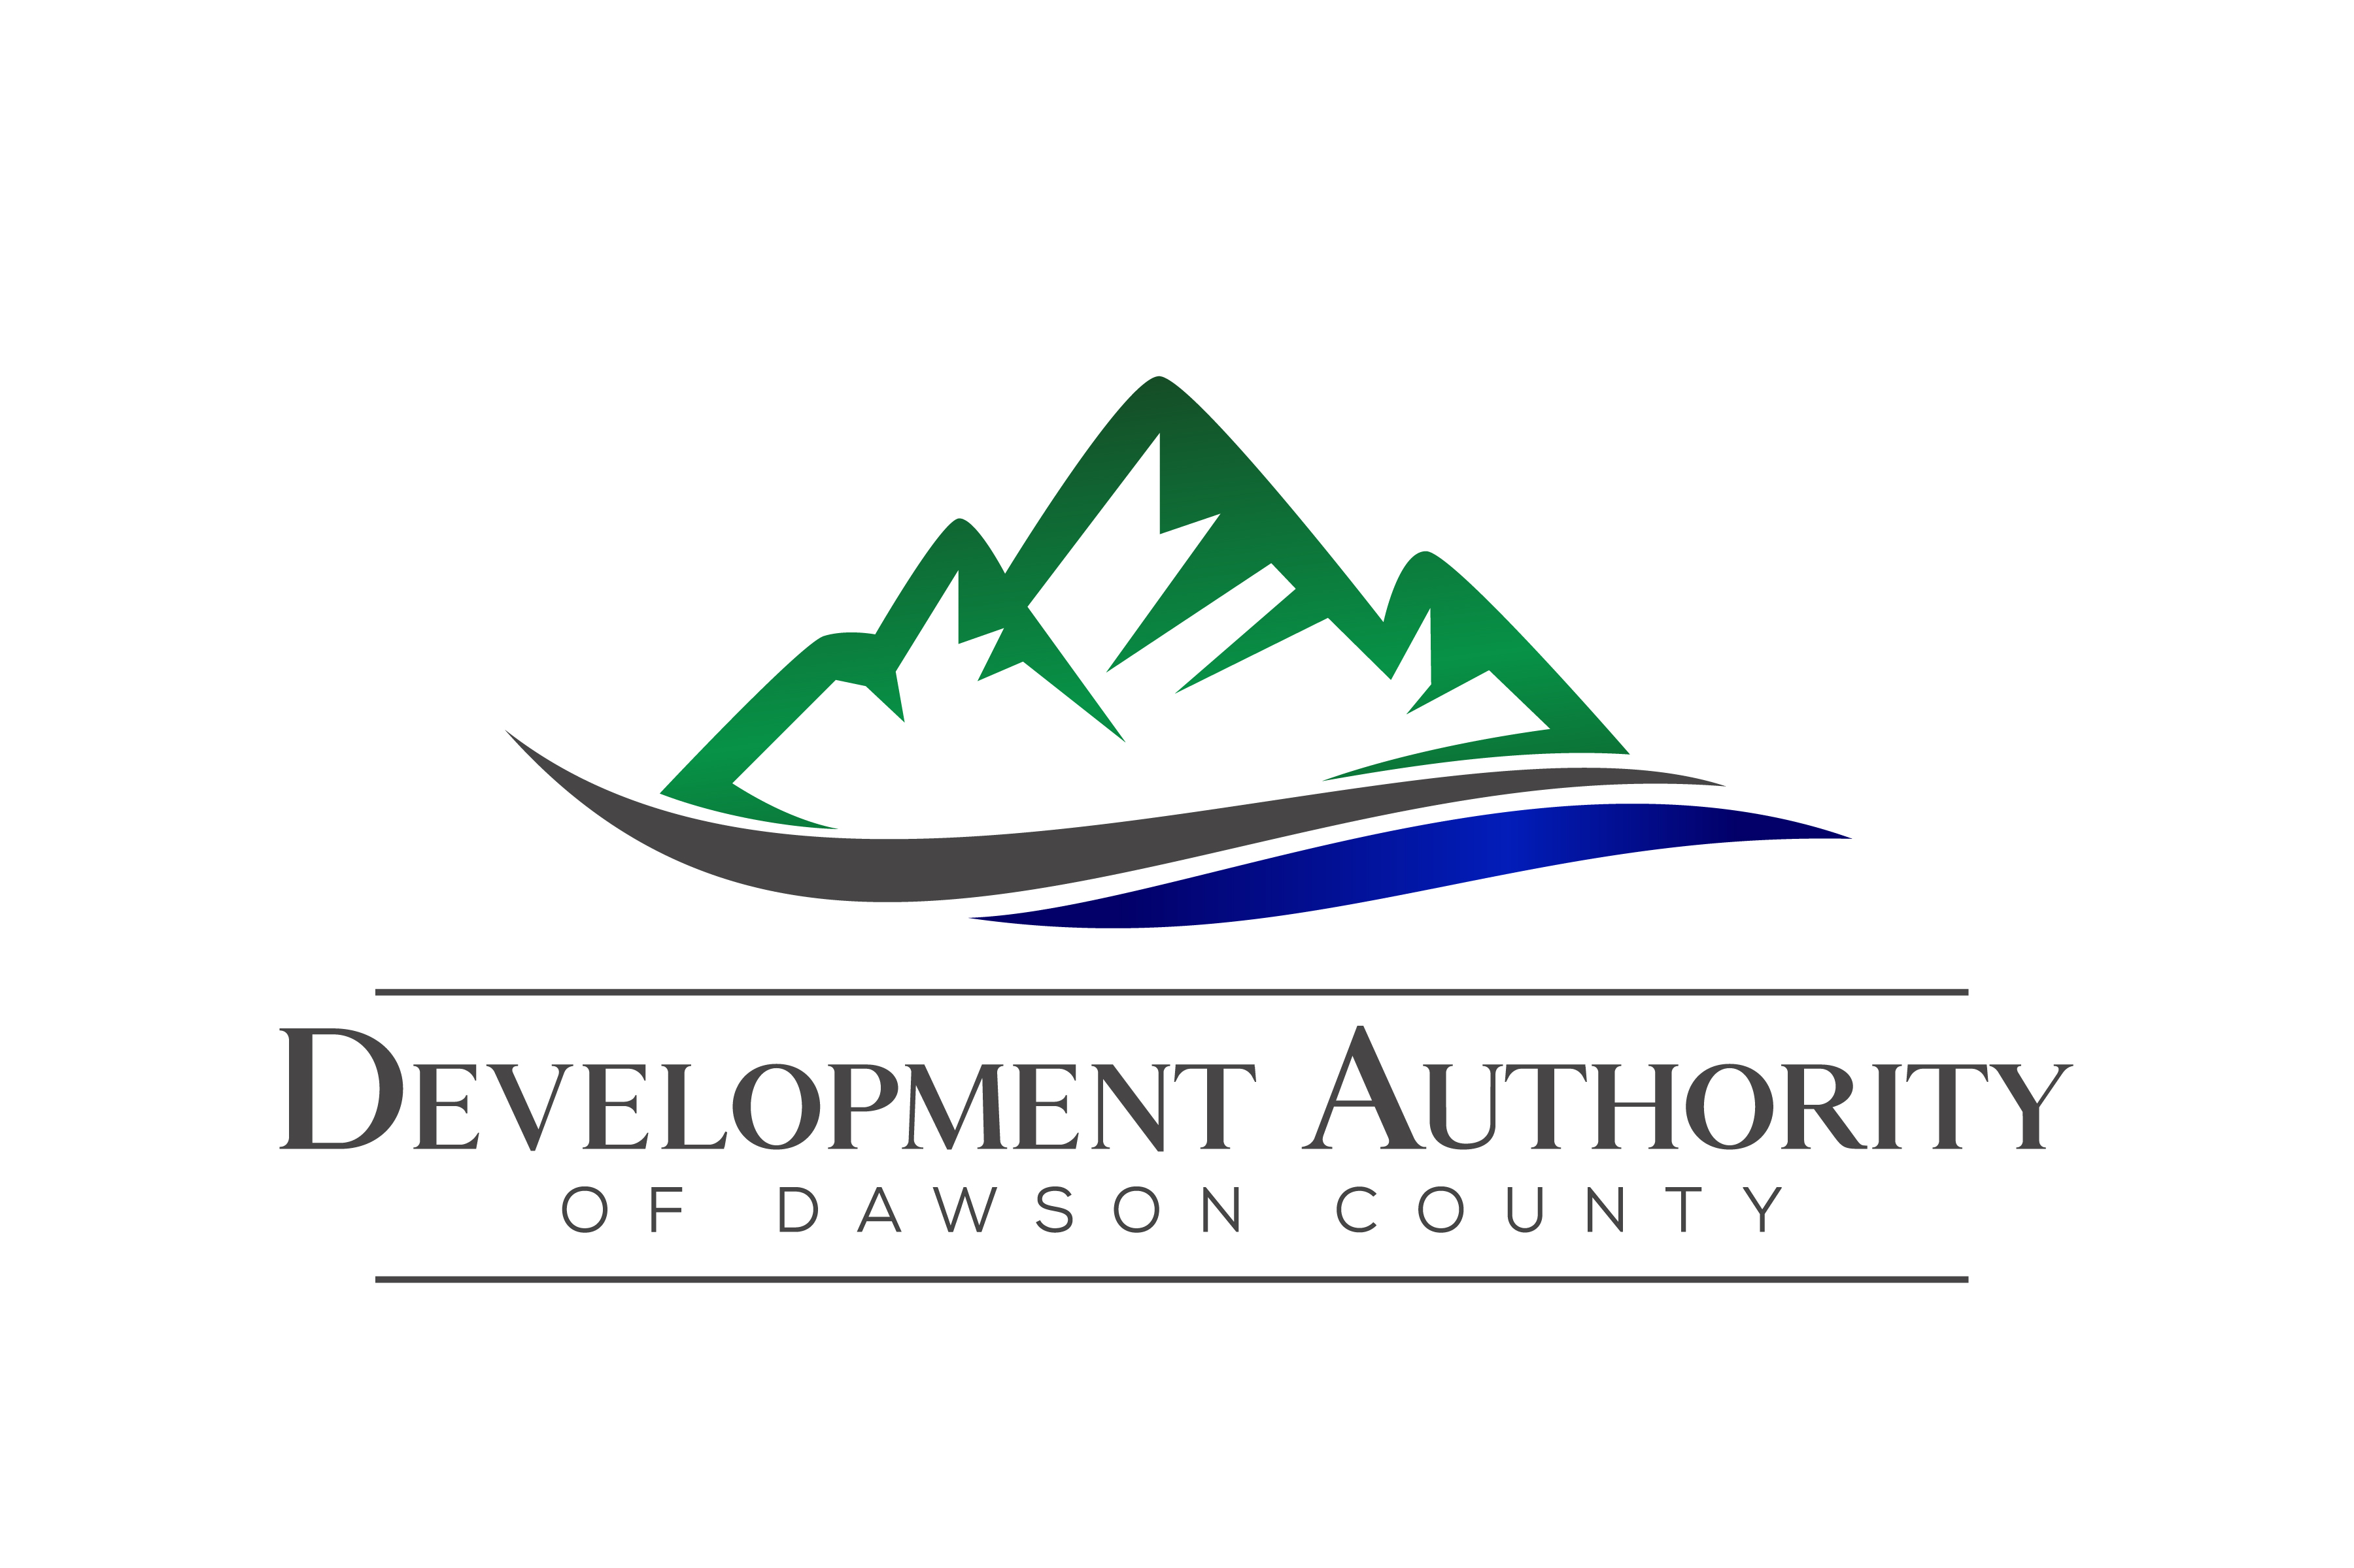
Development Authority of Dawson County
Regular Meeting
9:00 AM
October 27, 2020
44 Commerce Drive • Dawsonville, GA 30534

Call to Order Tony Passarello

Announcements Tony Passarello

Approval of the Quorum & Attendance Tony Passarello
Approval of the Agenda Tony Passarello

Approval of the Minutes Tara Hardwick
- July Regular Meeting Minutes

Financial Report Jere Allen

Old Business Tony Passarello
- Kroger Bond Update
- Economic Development Administration Grant Update
- Board Terms Review

New Business Tony Passarello

Economic Development Report Christie Moore/
Betsy McGriff

Ex-Officio Reports

Closed Executive Session for the Purpose of Discussing Real Estate

Adjourn Tony Passarello

