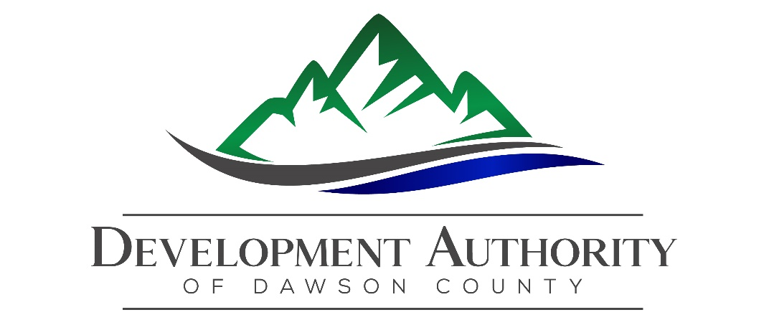

Development Authority of Dawson County
Special Called Meeting Minutes
December 1, 2020

Location: Meeting conducted at Dawson County Chamber of Commerce, 44 Commerce Dr., Dawsonville, GA & simultaneously remote meeting via video conference due to Covid19 Pandemic.

Attendees: Tony Passarello, Chair, Calvin Byrd, Vice Chair, Tara Hardwick, Secretary, Jere Allen, Treasurer, Brian Trapnell, Mike Ball, Gary Coates and Ex-Officio: Christie Moore. Betsy McGriff attending as Director of Economic Development.

Absent: None.

Guests: Representatives from Stewart, Melvin & Frost, LLP.

- Call to Order. Called to Order at 9:04 a.m. by Tony Passarello, Chair.

- Announcements. None.

- Approval of the advertised Location, Quorum & Attendance. The Chair requested a motion that the meeting was being held in the duly advertised location, a quorum was reached, and board members were in attendance in person or via telephone/video. Confirmation was made that the meeting was submitted to Dawson News & posted. Motion to approve advertised location, quorum and attendance was made by Mike Ball. Seconded by Gary Coates. Passed 7-0. Allen, Ball, Byrd, Coates, Hardwick, Passarello and Trapnell in favor. None opposed.

4. Old Business.
- None

5. New Business.
  - Peaks of Dawsonville: in process of arranging financing & preparing documents. Purpose of today’s meeting is to discuss the Bond Document, which has been reviewed by our attorneys. 1 final revision will be mid-January. Will have called meeting to approve final documents & move forward. Documents are submitted to the court for legal review prior to approval. Today the Board reviews the validation documents. Tara & Tony will validate the documents today, moving towards final document in January. Per Treadwell Syfan/Stewart Melvin & Frost: Authority approves & adopts bond resolution, which provides the authority to issue the bonds. Not to exceed $10,000,000 revenue bonds, maturing 10/1/23 (see attached). Steps are: adopt resolution, file for validation, come back to DADC to approve final terms (January).
Motion to adopt Bond Resolution for Peaks of Dawsonville Revenue Bond made
by Gary Coates. Motion seconded by Calvin Byrd. Motion passed 6-0. Allen, Ball,
Byrd, Coates, Hardwick, and Passarello in favor. Trapnell absent. None opposed.

6. Executive Session. Motion was made for Executive Session at 9:41 am by Gary
Coates. Motion seconded by Mike Ball. Motion passed 7-0. Allen, Ball, Byrd, Coates,
Hardwick, Passarello and Trapnell in favor. None opposed.
Motion was made at 10:06 am by Mike Ball to end Executive Session. Motion
was seconded by Gary Coates. Motion passed 5-0. Allen, Ball, Coates, Hardwick, &
Passarello in favor. None opposed. Byrd & Trapnell absent.

7. Adjournment. The Chair opened the floor to entertain a motion to adjourn the December 1, 2020 special called meeting. Mike Ball made a motion to adjourn the meeting. Tara Hardwick seconded the motion. Passed 5-0. Allen, Ball, Coates, Hardwick, and Passarello in favor. None opposed. Byrd & Trapnell absent. Meeting was adjourned at 10:07 A.M.

Attachments to these minutes on file: Bond Resolution document.

Respectfully submitted,

Tara Hardwick, Secretary

